|  |  |
| --- | --- |
| **Pure Water Application** | **System Analysis and design**  **Project** |

**Table of contents**

**Summary about the selected company:** 3

**SDLC Methodology** 4

**Planning Phase** 5

Gantt chart 5

Feasibility Study: 5

Economic feasibility: 5

Technical Feasibility: 7

Operational feasibility: 7

Project charter 8

**Analysis Phase** 9

Requirements Gathering 9

Functional Requirements: 9

Non-functional Requirements: 11

Use case diagram: 12

Data Flow Diagrams (DFD) 13

**Context Diagram** 13

**Level-0 DFD** 14

**Level-1 DFD** 15

Activity Diagram 16

Sequence Diagram 17

Class Diagram 18

**Design Phase** 19

Application Interfaces 19

**Table of Figures**

Figure 1: Waterfall model 4

Figure 2: Gantt chart 5

Figure 3: Context Diagram 13

Figure 4: Level-0 DFD 14

Figure 5: Level-1 DFD 15

Figure 6: Activity Diagram 16

Figure 7: Sequence Diagram 17

Figure 8: Class Diagram 18

Figure 9: Main interface 19

Figure 10: Customer Register interface 20

Figure 11: Set Location interface 21

Figure 12: Distributor Register Interface 22

Figure 13: Users Login interface 23

Figure 14: Customer profile interface 24

Figure 15: Distributor profile interface 25

Figure 16: Products menu interface 26

Figure 17: Product details interface 27

**Table of Tables**

Table 1 Tangible and intangible costs 6

Table 2: Tangible and intangible benefits 6

Table 3: Technical Feasibility 7

Table 4: Project charter 8

# **Summary about the selected company:**

Technology has become an important factor in facilitating our daily lives by finding smart solutions for many problems that effect lifestyle.

One of those problems is to get the daily need of water that needed in every Saudi house for daily using in drinking and cooking.

The proposed system is a smartphones application for android and iOS, it will facilitate the process of purchasing water, the customer can purchase water online. The application provides many services to customer as selecting the size and price of needed water, selecting the suitable payment method for him and free delivery.

Not only houses benefit of the application services but also, institutions, restaurants, schools and kindergartens. Any one need water can order form the application and it will delivers as fast as possible.

The application depends on locations, it will be using Google maps to determine the location of the customer to deliver the orders.

In addition, the customer can track the delivery location to know the arrival time. Moreover, the application will save customer data so that no need to fill in any data when order, just the first time of downloading the app and make the first order.

# **SDLC Methodology**

For the proposed application, we decided to choose the Waterfall Model, because of the clarity of the project requirements. When the requirements of the project are clear from the beginning, there will be no changes that require us to change in one of the steps.

In addition, the waterfall model is known as ‏a sequential design process that is very simple and easy to understand.

It divides the development process into phases, each must be completed before the next one begins. These phases are. Planning (gathering requirements), Analysis, Design, Implementation (coding and testing), Maintenance and Deployment.

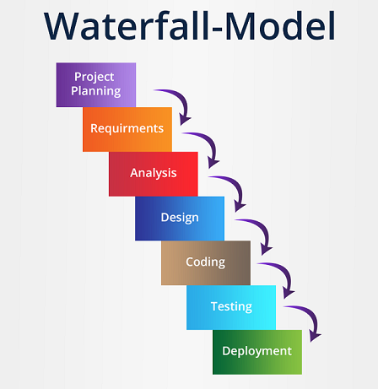

Figure 1: Waterfall model

# **Planning Phase**

## **Gantt chart**

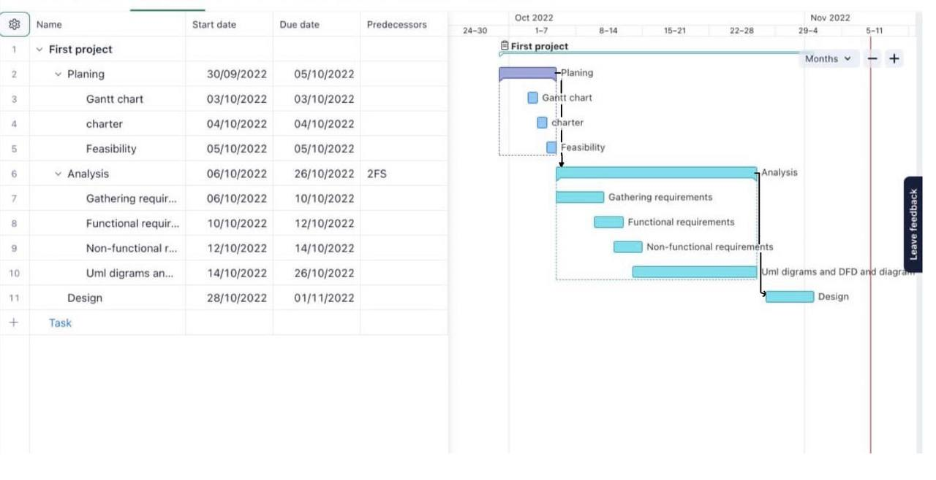

Figure 2: Gantt chart

## **Feasibility Study:**

## **Economic feasibility:**

This application will be downloaded from the app store for free. We will focus on the cost of the system production. The profit will earn from, distributors, they will pay 50$ monthly to register in the application.

**Tangible and intangible costs** :

Table 1: Tangible and intangible costs

|  |  |  |  |
| --- | --- | --- | --- |
| **Tangible costs** | **Cost** | **Intangible costs** | **Cost** |
| Laptop | - 600 $ | Operational efficiency | -100 $ |
| App store | -100 $ | Support and maintenance | -100 $ |
| Design and programing | -1000 $ | Marketing | -300 $ |
| **Total** | **-1700 $** | **Total** | **-500 $** |

**Tangible and intangible benefits**

Table 2: Tangible and intangible benefits

|  |  |  |
| --- | --- | --- |
| **Tangible benefits** | **Cost** | **Intangible benefits** |
| Distributors subscription profit | 2000 $ | Improve customer satisfaction |
| advertising cost | 500 $ | Positive impact on society |
| The app expected profits 2500 **$** yearly. | |
|

## **Technical Feasibility:**

We have a clear comprehensive requirements and good background and experience in application development that makes our application low risk

Table 3: Technical Feasibility

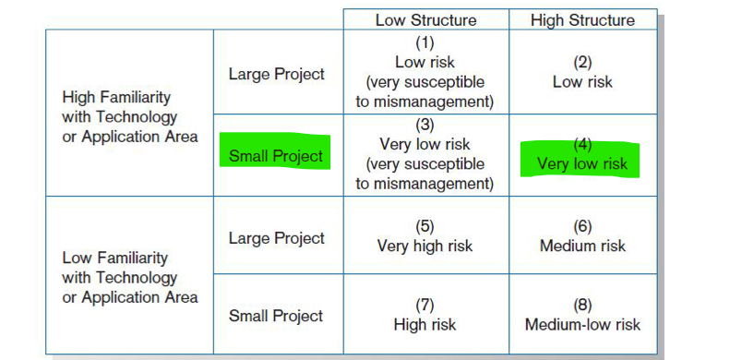

## **Operational feasibility:**



The application is beneficial to the customer it provides facilities to get pure water anytime, anywhere as fast as possible.

## **Project charter**

Table4: Project charter

|  |  |  |  |  |  |  |
| --- | --- | --- | --- | --- | --- | --- |
| Project charter | | | | | | |
| Project name | | Pure Water app | | **Project manager** | | Noura |
| Project start date | | 25/09/2022 | | **Project end date** | | 30/10/2022 |
| Last version date | | 06/11/2022 | | **Project sponsor** | | Hala |
| Project purpose statement | | | | | | |
| The proposed system is a smartphones application for android and iOS, it will facilitate the process of purchasing water, the customer can purchase water online. The application provides many services to customer as selecting the size and price of needed water, selecting the suitable payment method for him and free delivery. | | | | | | |
| Project objectives | | | | | | |
| * Facilitate water delivery process * Serve water providers to contact customers * Save customers time and effort * Financial return | | | | | | |
| Project scope | | | | | | |
| The application will serve almost all Saudi Arabia cities. The application will serve houses, cafes, restaurants, schools, kindergartens and even anyone need pure water for daily using. | | | | | | |
| Deliverables | | | **Risk** | | | |
| * Android version * IOS version | | | * Order loction * Delayed delivery to customers | | | |
| Financials | | | | | | |
| Project budget 2000 $ | | | | | | |
| Milestone | | | **Target completion date** | | | |
| Application implementation (Programming and testing) | | | 3, November | | | |
| Uploading application to Google Play Store and Apple Store | | | 06, December | | | |
| Project team | | | **Approval committee** | | | |
| Project manager | Noura | | **Business division head** | | Hala | |
| Team members | Raghad  Layan  Hala | | **Business unit head** | | Raghad | |
| **Finance manager** | | Layan | |

# **Analysis Phase**

## **Requirements Gathering**

Before identify the project requirements we should use some of the contemporary or traditional methods of requirements determination to collecting and generating a list of requirements, which is the first step in any system development process, we decided to use observation methods, which is simply observe the customer routines when the water bottles run out then recorded what they do, we have concluded the following requirements.

## **Functional Requirements:**

1. **Customer functional requirements**
   1. **Sign in**
   * The customer shall be able to create a new account
   * The customer shall be able to add address information, Postal code, street number, villa number or Building number.

* 1. **Login**
  + The customer shall be able to login using email and password
  + The customer shall be able to modify personal information
  1. **Make order**
  + The customer shall be able to open products menu
  + The customer shall be able to view the product details
  + The customer shall be able to select the product (brand, size, price)
  + The customer shall be able to add the product to cart
  + The customer shall be able to add another product to the cart
  + The customer shall be able to select the delivery time
  + The customer shall be able to select the delivery address
  + customer shall be able to receive order confirmation from distributer
  1. **Make Payment**
  + The customer shall be able to choose the payment option
  + The customer shall be able to receive the invoice of his order

1. **Distributor functional requirements**
   1. The Distributer shall be able to register
   2. The Distributer shall be able to login
   3. The Distributer shall be able to manage products

* Add products
* Modify products details
* Delete a product
  1. The Distributer shall be able to manage orders
* Confirm order
* Send confirmation to the customer with payment receipt

1. **Delivery functional requirements**
   1. The delivery captain shall be able to register
   2. The delivery captain shall be able to login
   3. The delivery captain shall be able to receives delivery location

## **Non-functional Requirements:**

1. **Performance:**

* The app load time must be less than five seconds.
* Response times must be less than five seconds.
* The system should receive updated information every 20 minutes.
* The application should be Available for use 24 hour per day 365 days per year.

1. **Capacity:**

* The system should deal with the increasing use and any size of the data without error.

1. **Usability:**

* The system should be easy to use by all kinds of users without a training or help

1. **Security and privacy:**

* This system should protect user data.
* The system should allow only registered users to access.

1. **Operational:**

* The application must be operated on android and iOS

## **Data Flow Diagrams (DFD)**

### **Context Diagram**

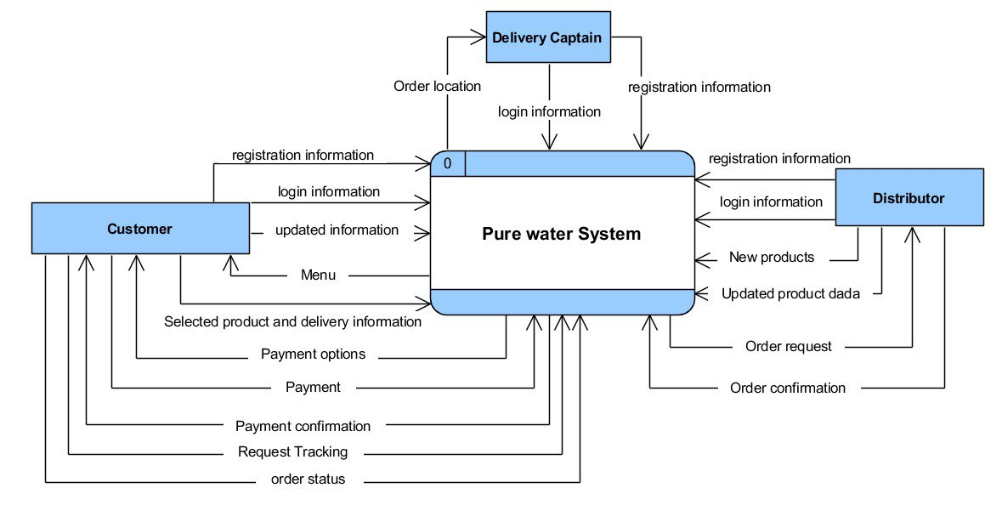

Figure : Context Diagram

### **Level-0 DFD**

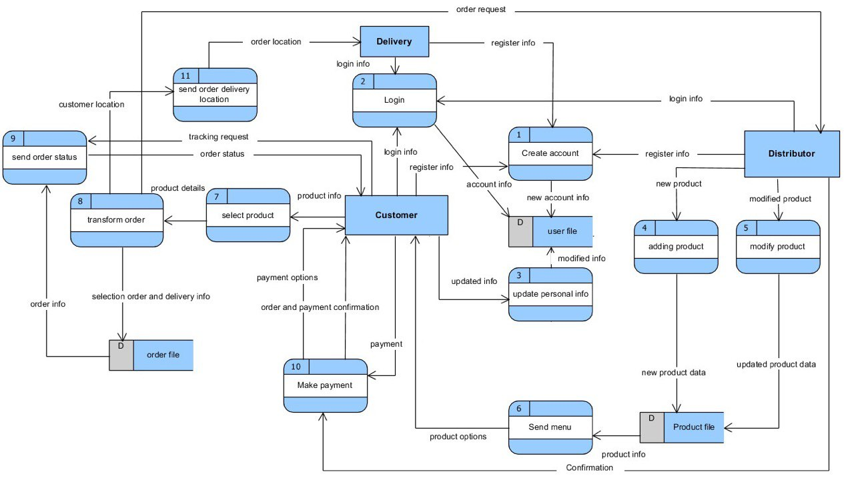

Figure : Level-0 DFD

### **Level-1 DFD**

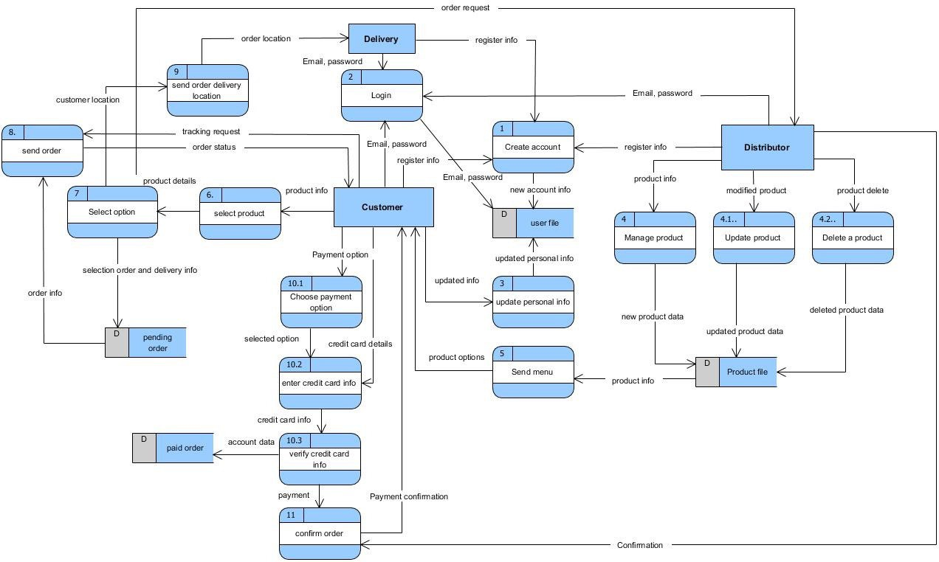

Figure : Level-1 DFD

## **Activity Diagram**

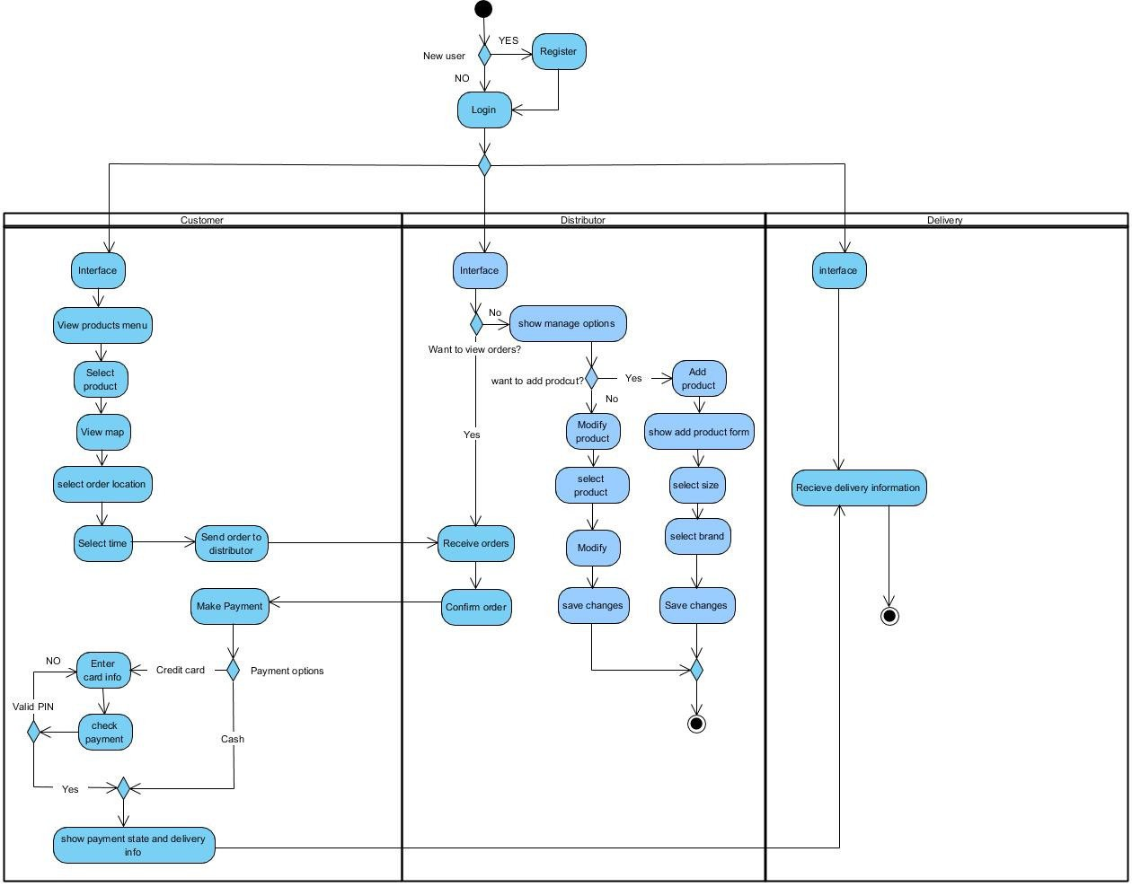

Figure : Activity Diagram

## **Use case diagram:**

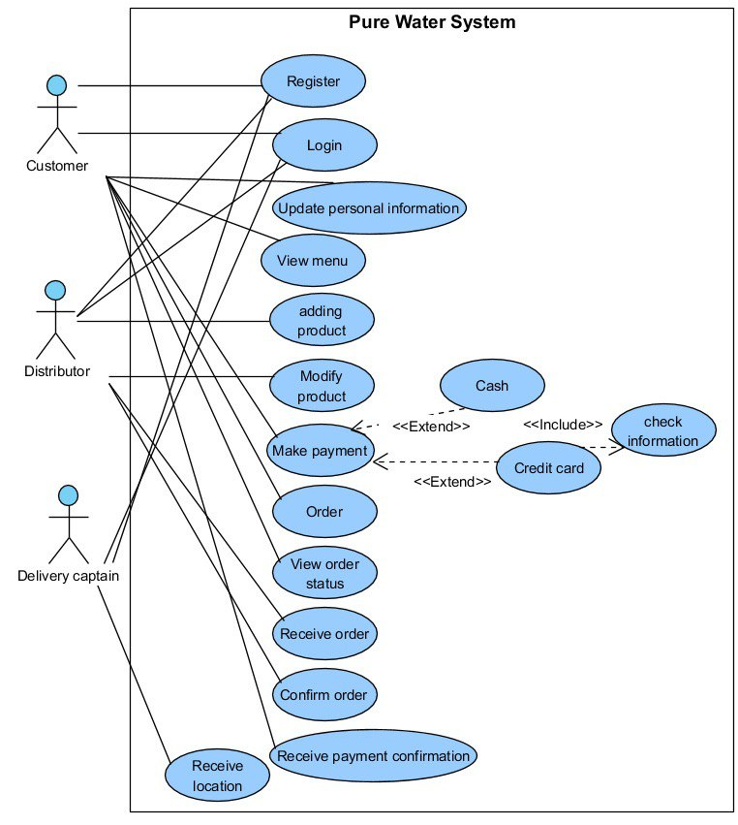

## **Sequence Diagram**

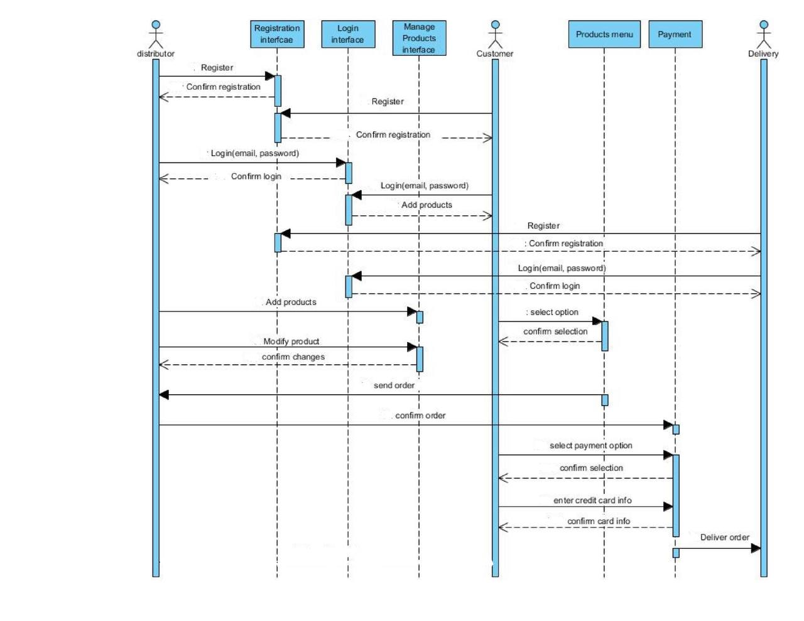

Figure : Sequence Diagram

## **Class Diagram**

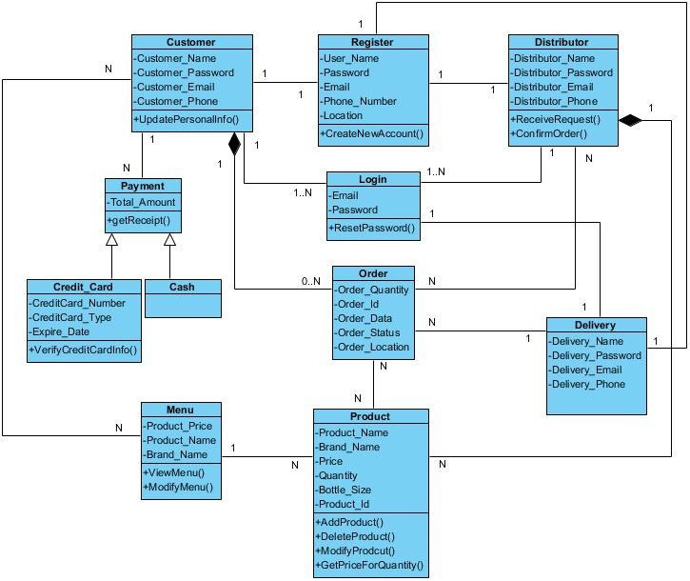

Figure : Class Diagram

# **Design Phase**

## **Application Interfaces**

**Main interface**

Figure : Main interface

**Customer Register interface**

Figure : Customer Register interface

**Mune interface**

**